Opinion: How the energy wealth fund links Jackdaw to our green energy future
The Aberdeen academics who proposed the UK's new £2bn energy wealth fund set out how government can make it work.
November 3rd 2026, 7:00 am
4 min read
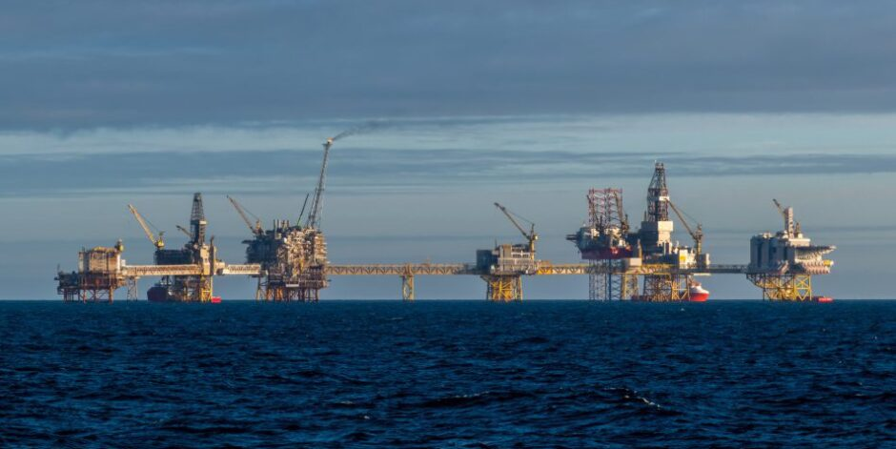© Shutterstock
Prof Paul de Leeuw, Robert Gordon University, and Prof John Underhill, Aberdeen University.
Paul de Leeuw and John Underhill proposed a plan to enable the North Sea to fund clean energy investment.
With winter approaching, Jackdaw approved, the Budget delivered, and COP31 weeks away, the UK has an opportunity to connect immediate energy security with long-term climate ambition. The energy wealth fund is a very welcome step towards that goal.
For an economy of the UK’s scale, the priority must be a coherent, long-term energy strategy that meets today’s needs while accelerating investment in tomorrow’s energy system. The North Sea can play a leading role in delivering both.
© Image: Big Partnership
Robert Gordon University Energy Transition Institute director Professor Paul de Leeuw in Aberdeen.
© Supplied by Aberdeen Uni
Professor John Underhill will help lead the debate at Offshore Europe in Aberdeen.
Jackdaw brings that relationship into sharp focus. Expected to begin supplying gas into the UK system within weeks, it underlines the importance of gas for heating homes, cooking, supporting industry and providing flexible electricity generation when renewable output is low.
Domestic production cannot insulate consumers from international gas prices, but it can reduce the volume of imports needed for a given level of demand and thereby provide energy and national security at a time of geopolitical uncertainty and supply tensions.
While domestic gas production to meet societal needs is a short-term objective, the strategic long-term priority is to reduce that demand while managing our remaining resources responsibly.
In August, we shared a proposal with the UK Government for a fund that ring-fences the tax revenues generated by continued domestic production. Its core principle was straightforward. While the UK continues to use oil and gas, a share of the tax revenues generated by domestic production should be invested visibly in reducing our future dependence on them. The decision to allow Jackdaw also demonstrates how continued domestic production can contribute to energy security while generating tax revenues that can support the transition.
The energy wealth fund provides an opportunity to put that principle into practice. The initial £2 billion commitment is a welcome starting point. The greater the fund’s scale, the greater its potential to accelerate investment, unlock private capital and deliver a lasting economic and industrial legacy from the North Sea. The additional capital announced for the National Wealth Fund in the Budget provides further scope to do this. A transparent, multi-year approach would provide greater certainty while recognising that oil and gas revenues will fluctuate and ultimately decline.
This approach could help align interests that are too often presented as competing. Government needs energy security and economic growth, industry needs investment confidence, the workforce needs credible routes into new roles and evidence that opportunities will arrive in time, and those focused on climate action need faster emissions reductions. While their priorities will not always align, linking revenues from domestic production to investment in reducing oil and gas dependence creates a clearer shared interest in delivering the transition.
Success will now depend on translating revenues into investment, and investment into infrastructure, projects, supply chain orders, and jobs. Renewable generation needs electricity networks, storage, ports, manufacturing, and skilled people. Targeting these enabling investments, alongside timely consenting and grid connections, could remove bottlenecks and significantly accelerate deployment.
The UK Continental Shelf (UKCS) provides a compelling platform. Its world-class engineering expertise, offshore operating experience and supply chains can support offshore wind, including floating wind, alongside carbon capture, hydrogen, and an increasingly integrated offshore energy system. However, this future requires deliberate choices. Businesses need confidence to invest, workers need opportunities to emerge in time, and communities need to be supported through the transition.
A managed and coordinated transition is therefore essential. The decline of existing activity and the expansion of new industries must be planned together. Losing experienced people, specialist companies and critical infrastructure before replacement opportunities mature would weaken the UK’s ability to deliver the transition itself.
The energy wealth fund, alongside a coordinated and pragmatic approach to domestic oil and gas, could help bridge that gap. Investment must arrive early enough for existing businesses and communities to participate in the next phase of the North Sea’s energy development. Success should be measured by projects brought forward, private investment unlocked and skilled people retained.
As COP31 approaches, the UK can demonstrate that energy security and climate ambition need not be competing objectives, and that climate ambition can be underpinned by industrial strategy. With sustained investment and strategic coordination, it can turn the challenge of a declining basin into a national opportunity.
The prize is to use the UKCS’s remaining resources and revenues, together with its infrastructure, supply chain and expertise, to help build the energy system and industries that will underpin the UK’s future economy.
Prof Paul de Leeuw is the director of Robert Gordon University’s Energy Transition Institute. Prof John Underhill is the director for energy transition at Aberdeen University.

